Public Relations Committee activity in 2011-2012

NOW TV 杏林在線 interview (June 2011)

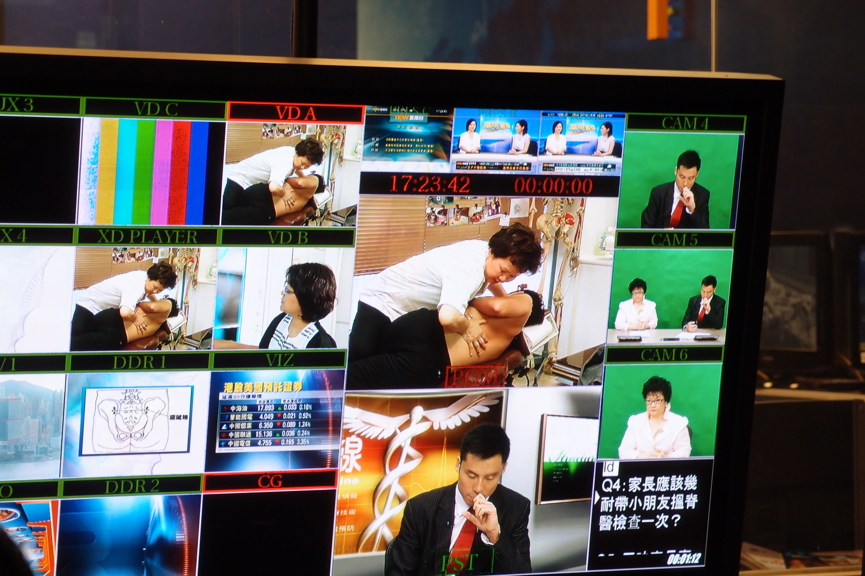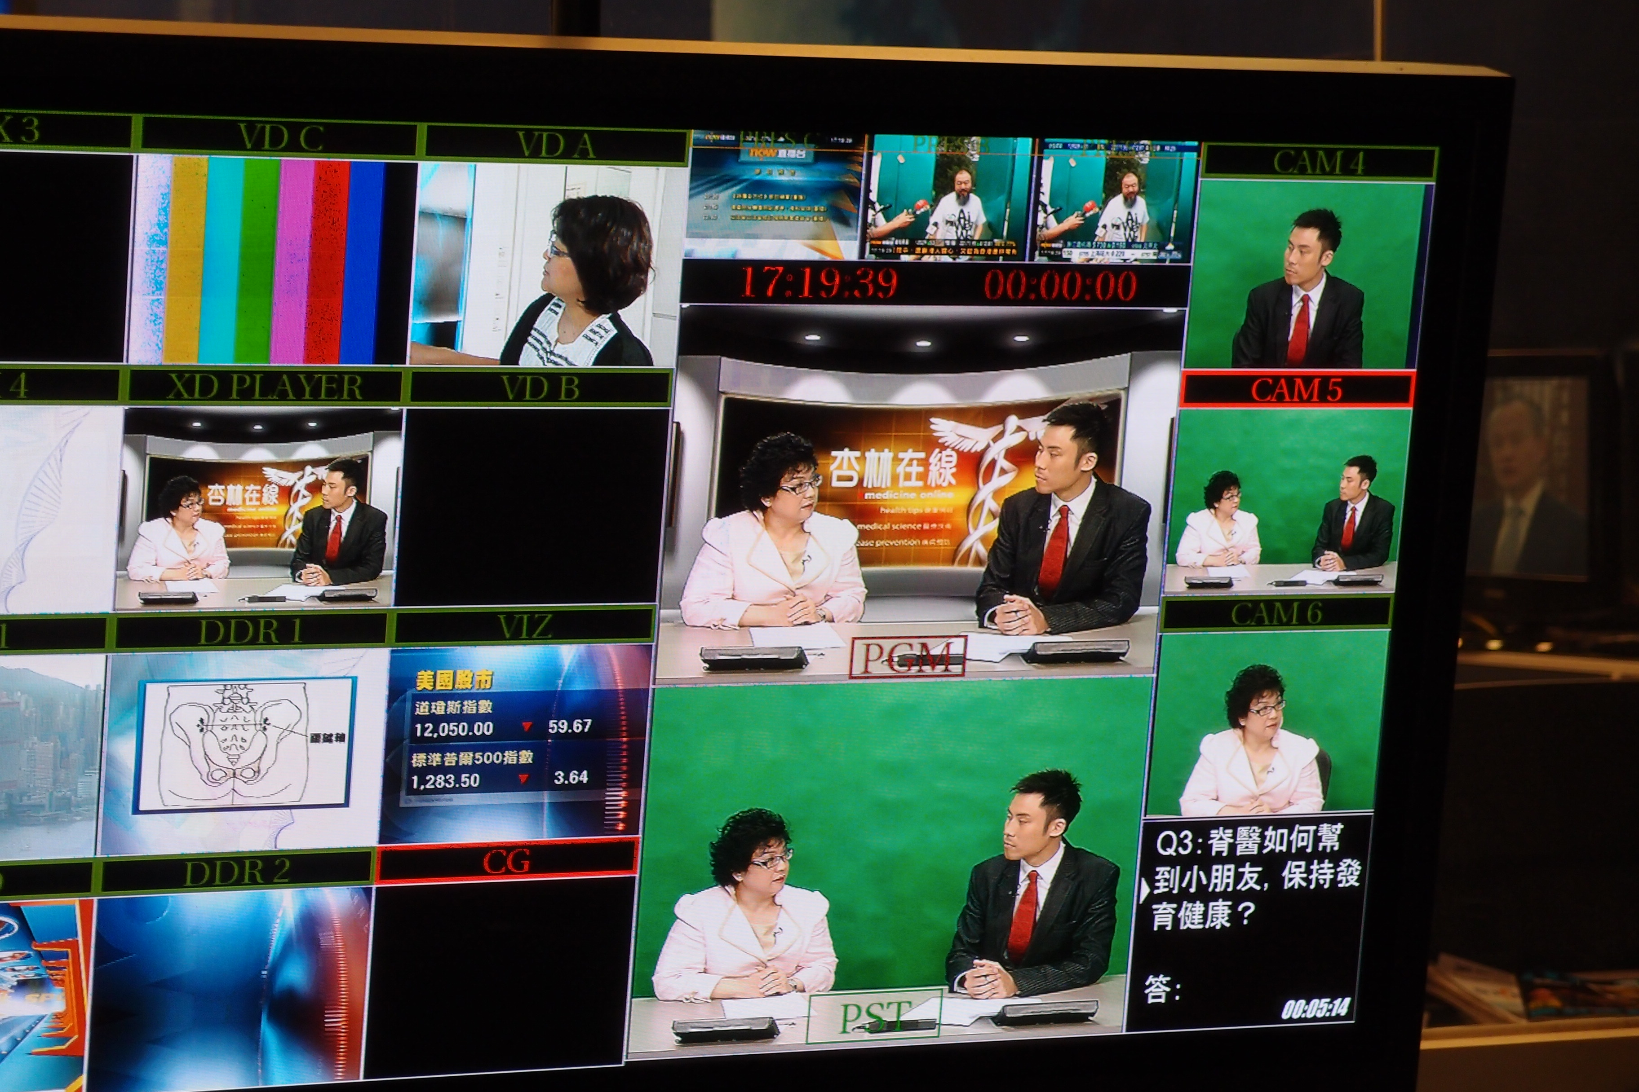

1st episode: What is Chiropractic? – presented by Dr. Edward Lee
2nd episode: Chiropractic and pregnancy patient – presented by Dr. Sandra Leung
3rd episode: Relationship of spinal health and children development – Dr. Sophia Ng

China Daily interview ( June 2011)

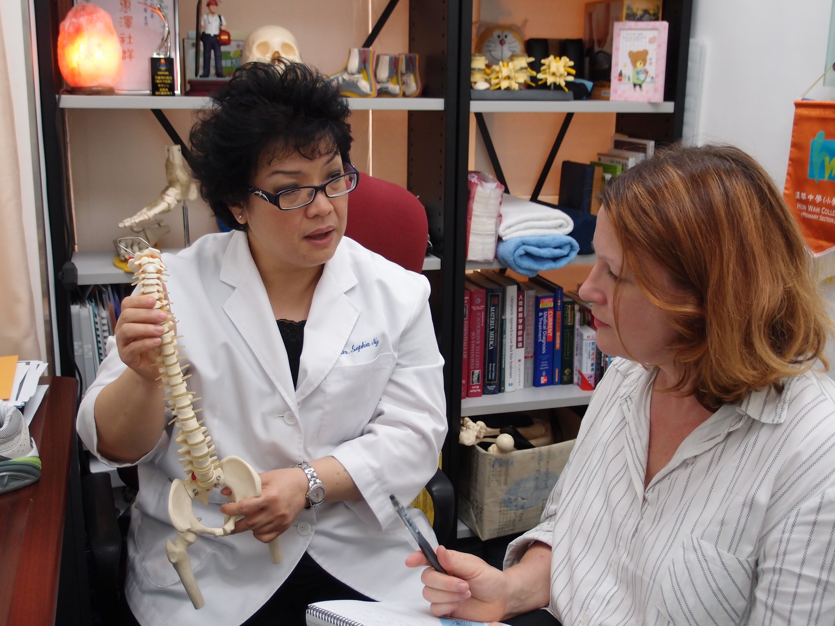

Topic: Curse of iPhone by Dr. Sophia Ng
Content of interview is about spinal health of city people has been altered by bad posture from over use of iphone, ipad and Blackberry phone etc. Suggest to maintain proper posture and routine exercises is the best preventive measure.

Spinal and Foot Scanning in Hong Kong Housing authority in Wong Tai Shin:
By Dr. Michele Zhou
Dr. Zhou started with spinal and foot check up for 30-45 people, handed out HKCA's general chiropractic education pamphlet and posture advices when appropriate. The whole event lasted about 2 hours.

Senasia Travel Service Ltd. – GD Golfer’s Club health talk
Topic: Golf Injuries: prevention & management through Chiropractic
By: Dr. Stanley Lum, Dr. Karen Chan and Dr. Leonard Wong
The health talk is arranged by Senasia Travel magazine to the Golfer’s Club members and the interested parties. The first section is the presentation and the second section is the demonstration of exercises. A booth is also set up in the venue for any Q and A for the participants.

TVB Health interview 健康奇案錄 (October 2011)

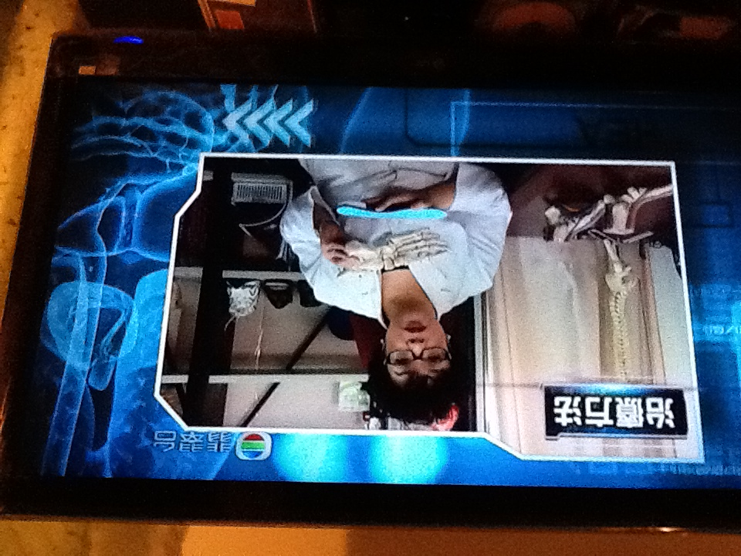
Topic:
1st episode: Carpal Tunnel Syndrome by Dr. Claudia Ng
2nd episode: Plantar Fasciitis by Dr. Sophia Ng

Giordano Staff Health talks (March 2012)

Topic: How to protect shoulder, elbow, and wrist by Dr. Leonard Wong and Dr. Alex Pak to office staffs
Topic: How to protect back, knee and feet by Dr. Leonard Wong and Dr. Alex Pak to Warehouse staff
Health talk to Giordano is the second year events to their staff. Each time the response is very good and hopefully we can arrange more interested topic for them in the future.

Northern Lamma School (March 2012)

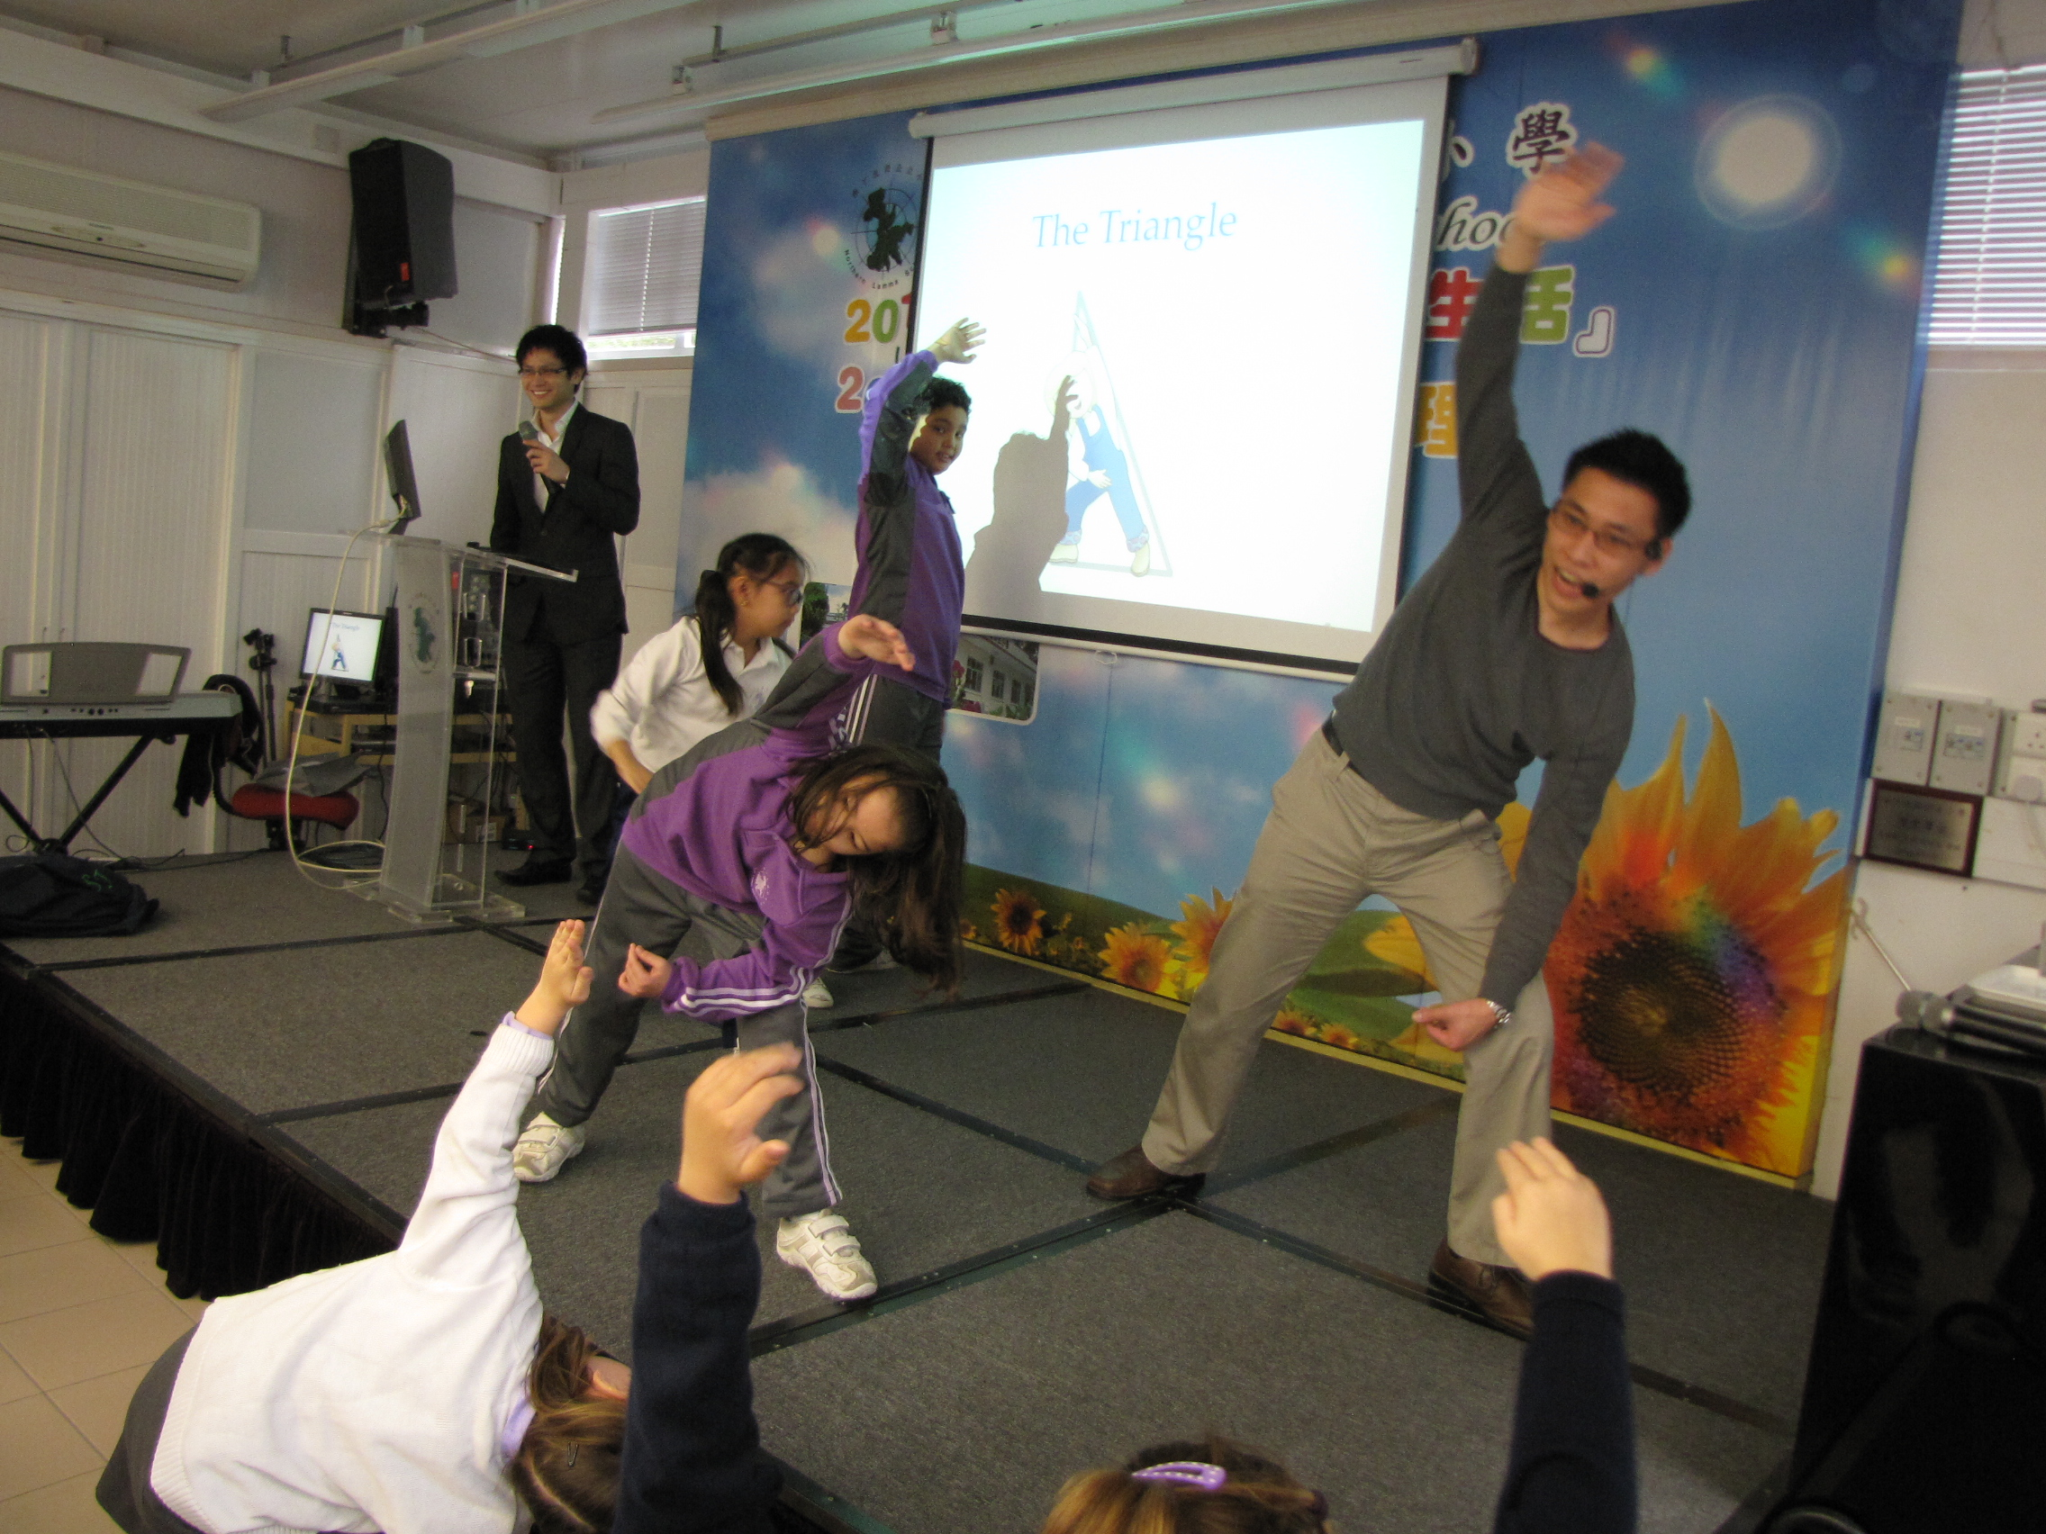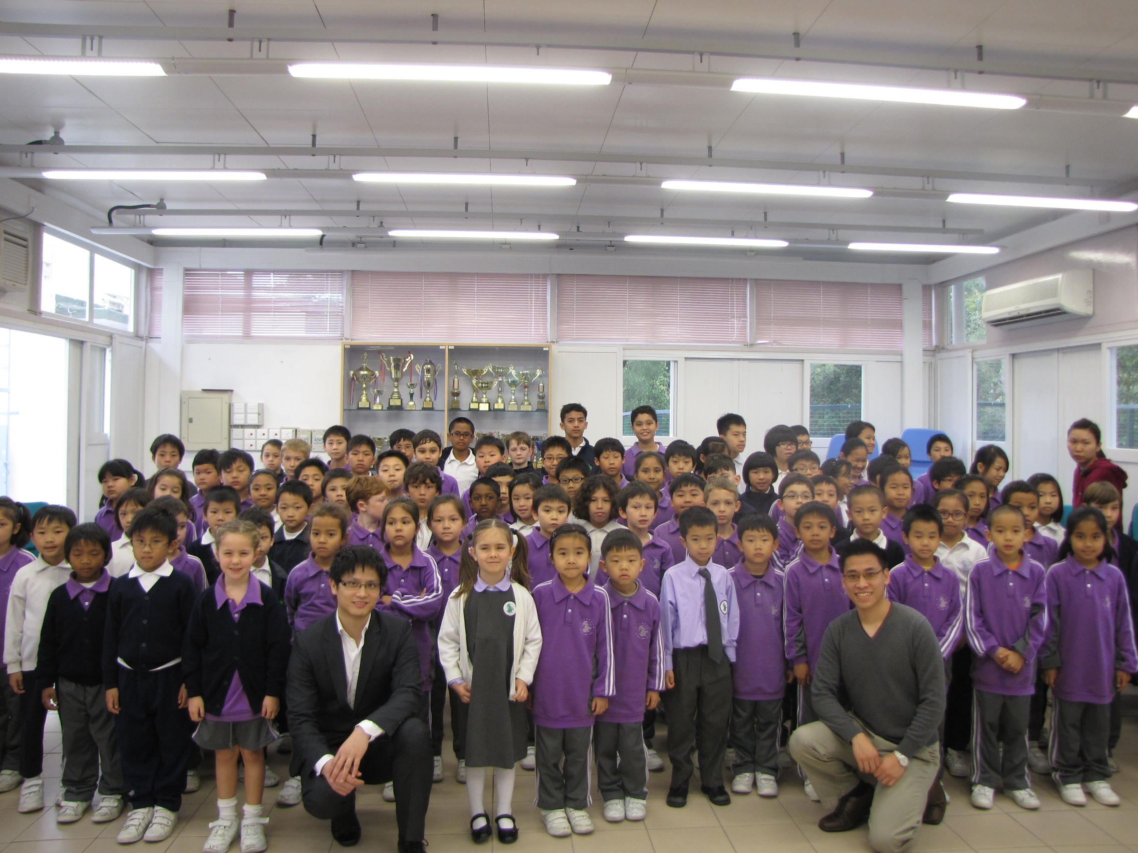

This invitation is by Northern Lamma School located in Lamma Island. It is a multi-cultural primary school. This is one of their activities on the “Health Day” on campus.
Topic: Spinal Health and exercise to school children by Dr. Leonard Wong and Dr. Alex Pak

Maryknoll Father School Career Talk (April 2012)
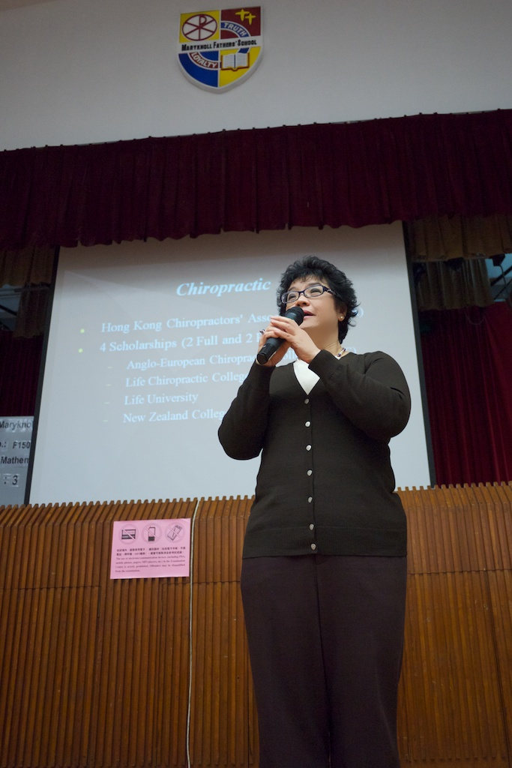

HKCA Chiropractic Scholarship: by Dr. Sophia Ng
This is the first time introduction of Chiropractic scholarship program from HKCA to the potential students who may not have much exposure of Chiropractic treatment. Students can consider as another option to choose from is they are interested in becoming health care professional.

